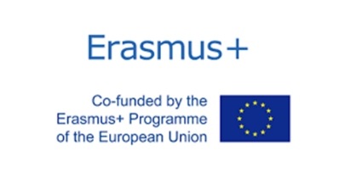**FORM FOR THE RECEPTION OF STUDENTS**

*Istituto Tecnico Economico e Tecnologico “A. BASSI” -* LODI (ITALY)

*Pouilly-en-Auxois (Dijon) - FRANCIA*

**Personal details**

|  |
| --- |
| Surname: First name: |
| Date of birth: Course: Sex: boy / girl |
| Address: City: |

**Contact information**

|  |
| --- |
| ***Phone numbers*** |
| My mobile: Father's mobile: Mother's mobile: |
| ***Emails @:*** |
| My email: Father's email: Mother's email: |
|  |

**I introduce myself**

|  |
| --- |
| Age: |
|  |
| I learn English since: |
|  |
| I consider myself (personality): |
|  |
| I eat everything, especially I love to eat: |
|  |
| I am vegetarian, especially I like to eat: |
|  |
| I have allergies to these foods: |
|  |
| I take these medicines: |
|  |
| I have this chronic illness: |
|  |
| I have allergies to these animals: |
|  |
| I have these pets at home: |
|  |
| I CAN / CANNOT stay in a house with pets. |
|  |
| I would prefer my roommate to be a BOY / GIRL / INDIFFERENT. |
|  |
| My roommate will have a SINGLE / SHARED room. |
|  |
| My hobbies and interests: |
|  |
|  |